STEP 1 :
COMMAND: composer -v
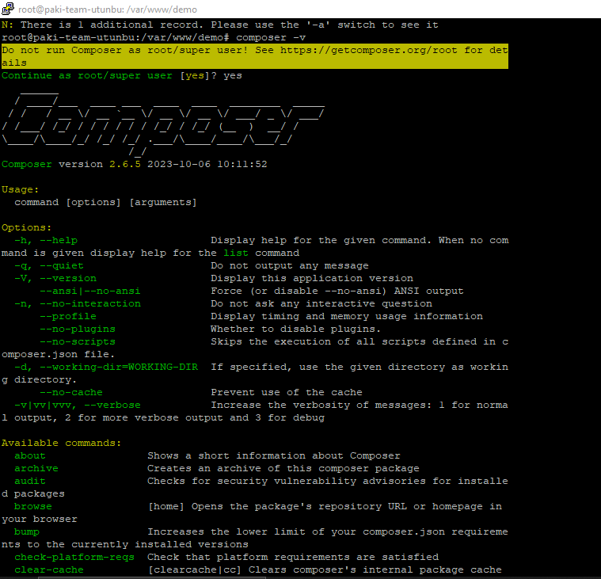
STEP 2:
apt show php
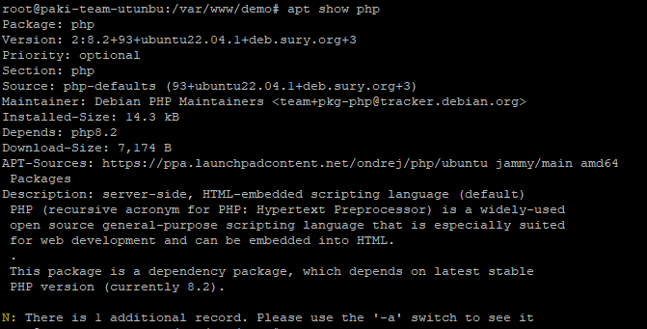
STEP 3 :
composer create-project laravel/laravel techion 9.0
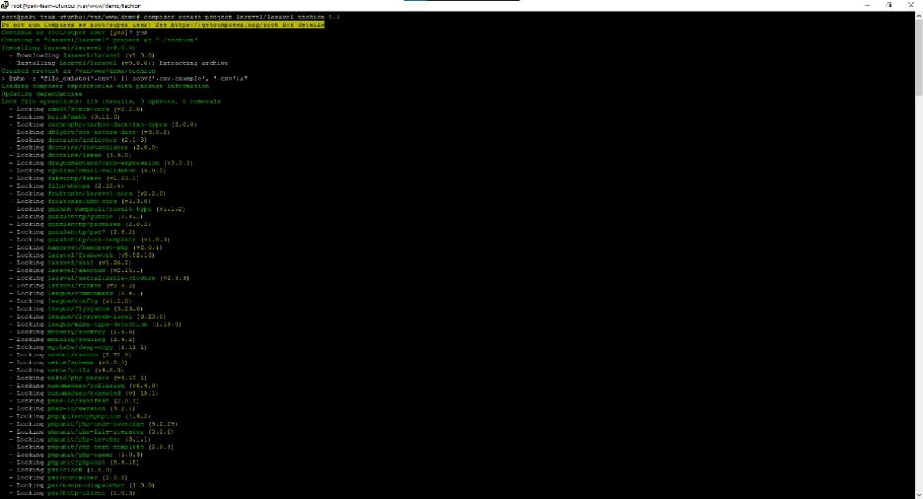
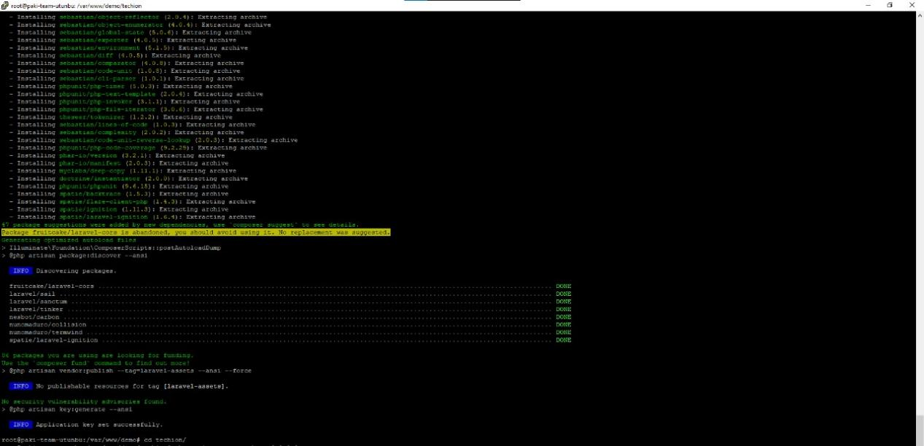

For Auth
Cammand Used
composer require laravel/ui
php artisan ui bootstrap –auth
npm install && npm run dev
php artisan migrate

For Nginx
STEP 1 :

There are two directories within a Laravel application that need to be writable by the server: storage and bootstrap/cache. Within these directories, the server will write application-specific files such as cache info, session data, error logs, etc.
To allow this to happen, you need to update the permissions of storage and bootstrap/cache so they are owned by the system user your web server is running as.
Following command are used for permissions
chown -R www-data storage
chown -R www-data bootstrap/cache
STEP 2 :

At this point, everything is set up within our application, we just need to configure our server to run it.
Within /etc/nginx/sites-available/ create a new file with the following content.
server {
listen 80;
listen [::]:80;
server_name pk-dev-team.com;
root /var/www/demo/techion/public;

add_header X-Frame-Options "SAMEORIGIN";
add_header X-Content-Type-Options "nosniff";

index index.php;

charset utf-8;

location / {
try_files $uri $uri/ /index.php?$query_string;
}

location = /favicon.ico { access_log off; log_not_found off; }
location = /robots.txt { access_log off; log_not_found off; }

error_page 404 /index.php;

location ~ \.php$ {
fastcgi_pass unix:/var/run/php/php8.2-fpm.sock;
fastcgi_param SCRIPT_FILENAME $realpath_root$fastcgi_script_name;
include fastcgi_params;
}

location ~ /\.(?!well-known).* {
deny all;
}
}

Next, to enable this config we need to symbolically link the file to the /etc/nginx/sites-enabled directory.
To do this, run the following command
sudo ln -s /etc/nginx/sites-available/techion /etc/nginx/sites-enabled
sudo nginx -t
restart Nginx to make the changes take effect:
systemctl restart nginx

